Antoniette M. Guglielmo

**Bar, Alfred H. Jr. (1902-1981) Word count: 523**

Alfred H. Barr, Jr. was an art historian and the founding director of the Museum of Modern Art, or MoMA, in Manhattan, New York, from 1929 to 1943. Upon assuming the post in August 1929, the young Barr took on the job of establishing the institution as America’s first and premiere museum devoted exclusively to modern art. His vision included developing an intellectual foundation for the development of modern art and popularising it for the public. As part of this work, Barr created new collection areas not previously conceptualized as part of an art museum, such as film and video, photography, architecture and design, and industrial art. In addition, he conceptualised a canon for the development of modern art and the origins of abstraction, diagramming it in the exhibition catalogue, *Cubism and Abstract Art* (1936). During his tenure, he organised more than 100 exhibitions, largely focused on European modernism. Barr was dismissed as Director in 1943 by the chairman of MoMA’s board of trustees, but stayed involved with MoMA in various capacities until 1968.

The founding mission in 1929 established MoMA “for the purpose of encouraging and developing the study of modern arts and the application of such arts to manufacture and practical life and furnishing popular instruction”. Towards these ends, Barr simultaneously historicised and popularised modern art. Along with the traditional departments of Painting and Sculpture, Drawings and Prints, and Illustrated Books, he designated new collection areas, eventually establishing an Architecture and Design Department (1932), a Film Library (1935), and a Department of Photography (1940). The Department of Architecture and Design elevated the stature of design as an art form on par with the other disciplines. Philip Johnson (1906-2005) directed the Department from 1932 to 1934 and from 1946 to 1954. The *Useful Objects* exhibition series that ran from 1938 to 1950 was especially popular and featured gadgets of sophisticated designs in store-like displays. In 1940, the Museum created a Department of Industrial Design with Edgar Kaufmann, Jr. (1910-1989) as its director. Kauffman directed the seminal *Good Design* exhibition series (1950-1955), which solidified the institution’s leadership in the field of international modern design.

Barr established an intellectual framework for presenting modern art. He developed the now iconic diagram, which he reproduced on the cover of his catalogue Cubism and Abstract Art (1936), published in conjunction with an exhibition of the same title. It represented the history of modern art as a series of progressive movements or “isms” linked by arrows that ultimately lead to the emergence of abstraction. In order to increase public understanding and appreciation of the development of modern art, Barr introduced special lighting in the galleries, explanatory wall text, and illustrated, scholarly exhibition catalogues.

**References and Further Reading**

Bee, H. and Elligott, M. (eds.) (2004) *Art in Our Time: A Chronicle of the Museum of Modern Art*. New York: The Museum of Modern Art.

Kantor, S. (2002) *Alfred H. Barr, Jr. and the Intellectual Origins of the Museum of Modern Art.* Cambridge, MA: MIT Press.

Sandier, I. and Newman A. (eds.) (1986) Defining Modern Art: Selected Writings of Alfred H. Barr, Jr., 1926-64. New York: Harry N. Abrams.

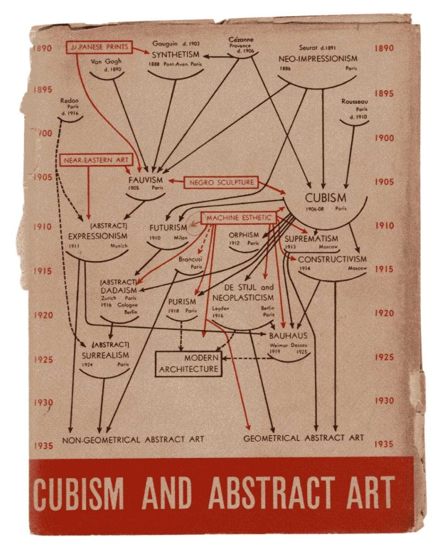 <http://www.artnews.com/2012/10/02/momaabstractionfaceboo/>

Jacket for the exhibition catalogue *Cubism and Abstract Art*, with a chart of modernist art history by Alfred H. Barr, Jr. Offset, printed in color. New York: The Museum of Modern Art, 1936.

ALFRED H. BARR, JR. PAPERS, THE MUSEUM OF MODERN ART ARCHIVES,

NEW YORK/COURTESY MUSEUM OF MODERN ART.